Name:G Shivani

Roll no:2520090046

SKILL WEEK-2

Session-3
Task1: To Apply Escape Sequences, Store Command History, Navigate Previous Commands, Navigate Next Commands, Update Input Buffer, Test Recall Functionality
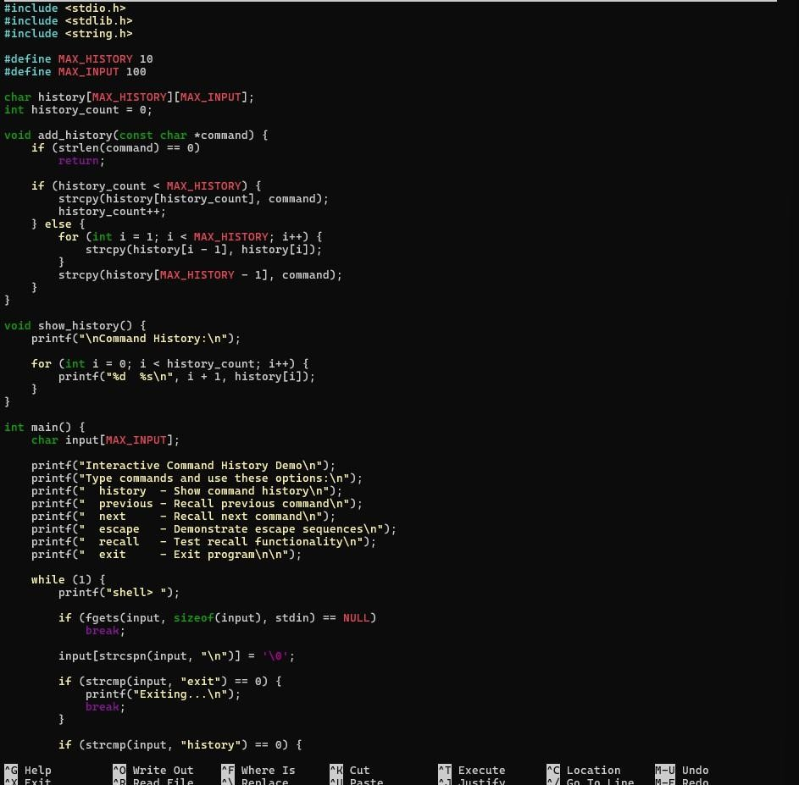

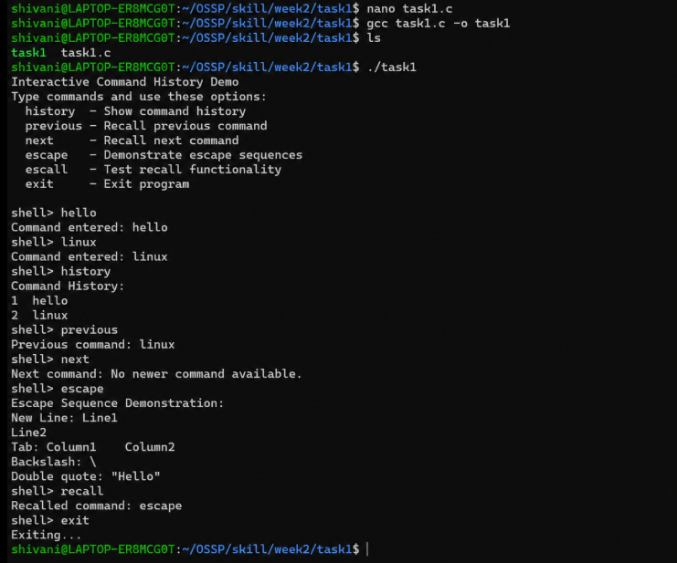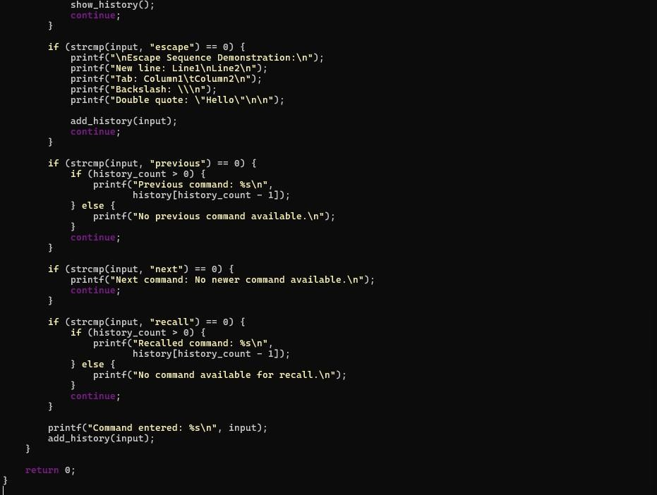

Observation: The program successfully demonstrated command history management and command recall functionality. Previously entered commands were stored and displayed using the history option. The previous option recalled the most recent command, while the next option checked for a newer command. Escape sequences such as newline, tab, backslash, and double quotes were also displayed correctly. The recall option successfully recalled the previously entered command, and the program terminated correctly using the exit command.
Task2: To Allocate Buffers Dynamically, Resize Arrays, Prevent Buffer Overflow, Manage Linked Lists, Release Memory Correctly, Verify with Valgrind
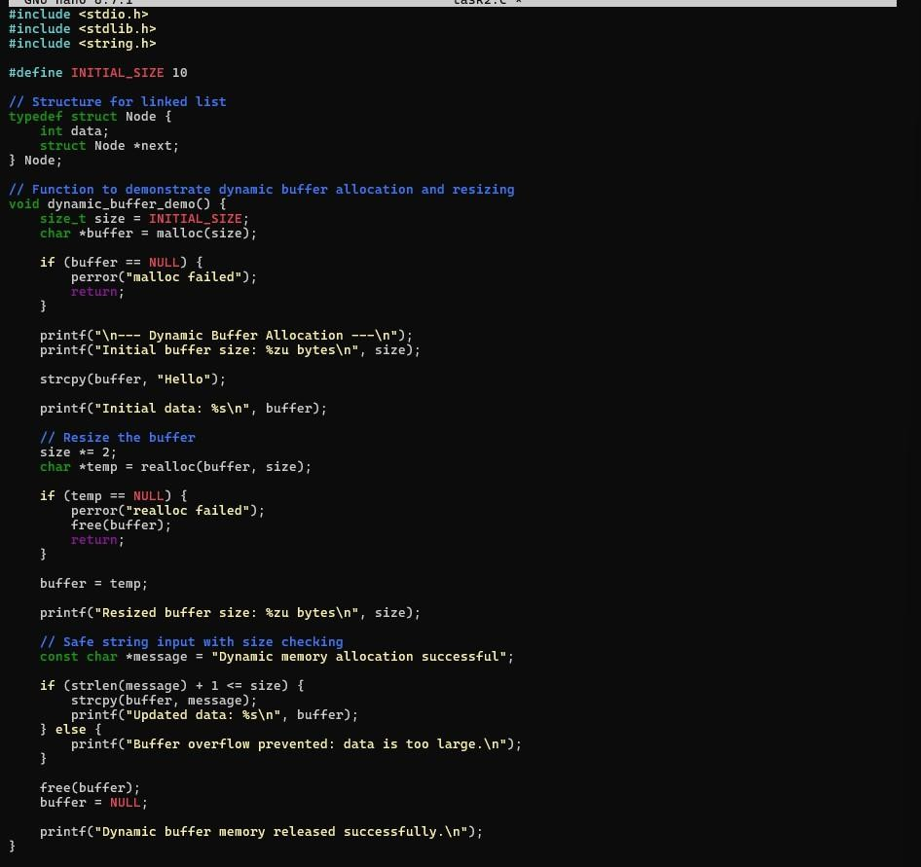

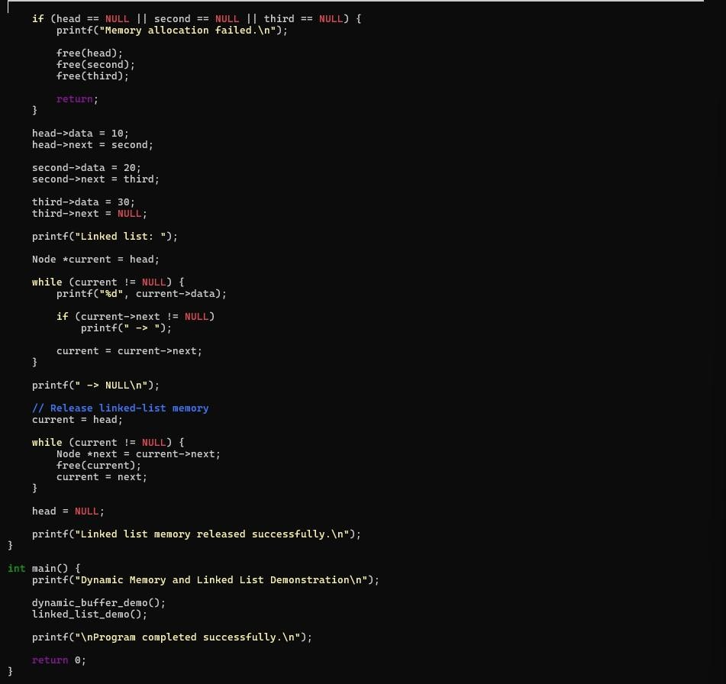
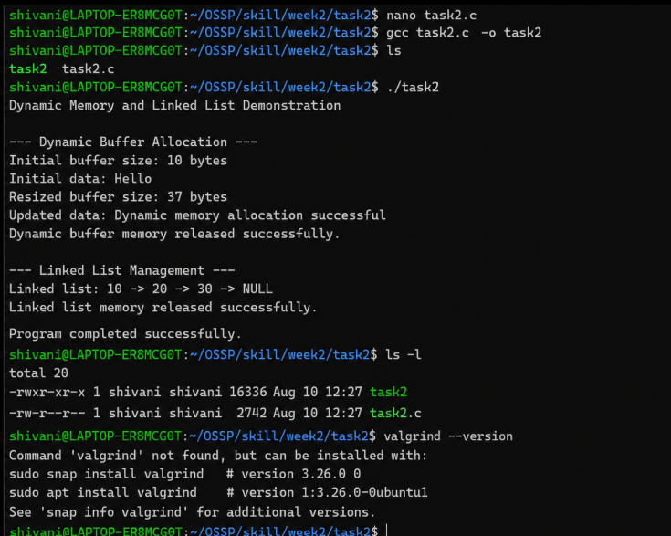

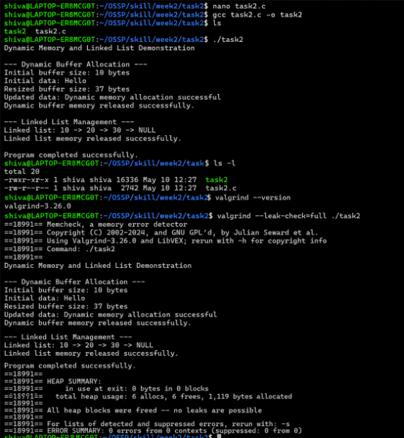
Observation: The program successfully demonstrated dynamic memory management using malloc(), realloc(), and free(). The buffer was dynamically allocated and resized according to the required data size, preventing buffer overflow. A linked list was created using dynamically allocated nodes, traversed successfully, and all allocated nodes were released using free(). Valgrind verification reported 0 bytes in use at exit, 6 allocations and 6 frees, and 0 errors, confirming that the program released the allocated memory correctly without memory leaks.

Session-4
Task1: To Split Input into Tokens, Identify Delimiters, Handle Whitespace, Create Token Structures, Validate Token Streams, Debug Parsing Output.
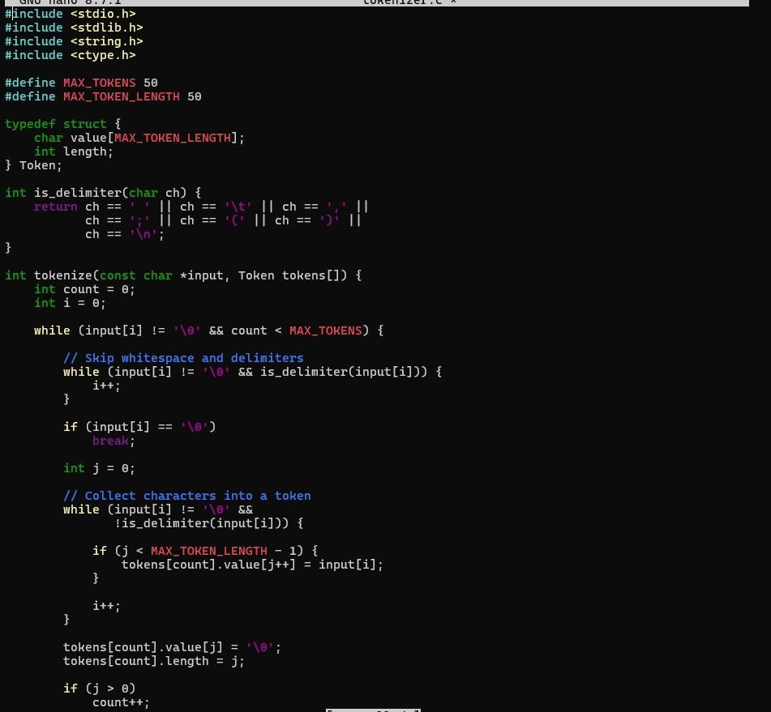

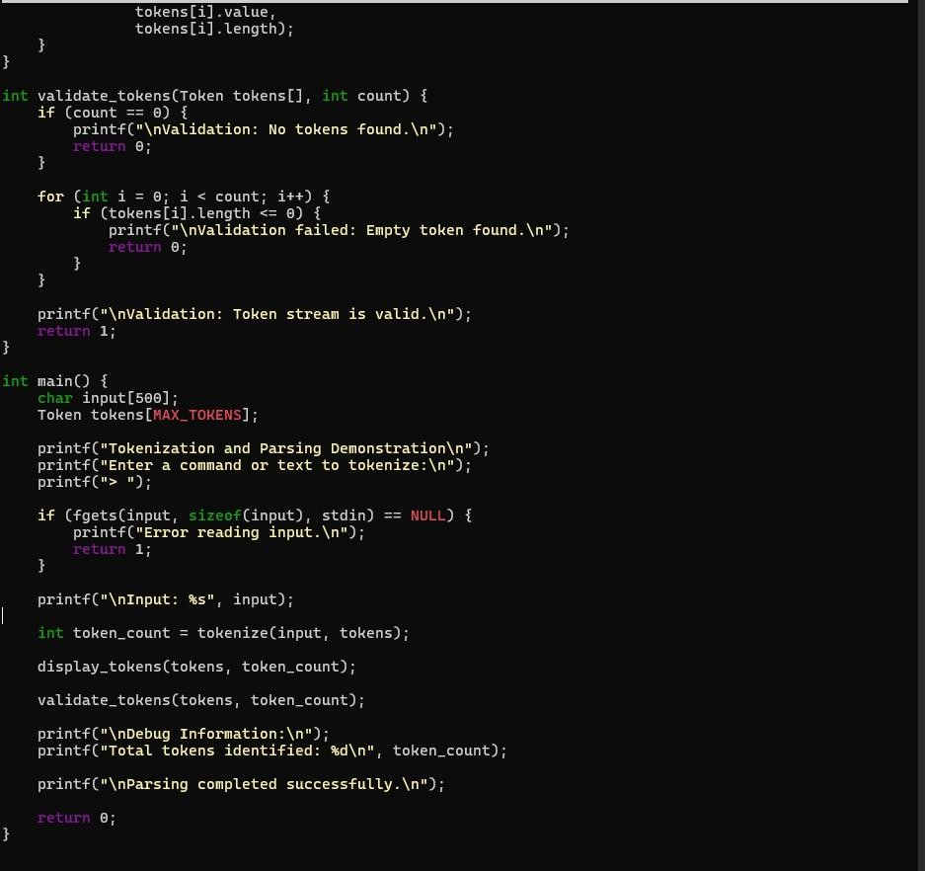

Observation: The tokenizer program successfully divided the given input into individual tokens using whitespace and delimiters. The tokens were stored in a structured format along with their lengths. The token stream was validated successfully, and debug information displayed the total number of tokens identified. The program completed the parsing operation successfully without errors.
Task2: To Design Parser Logic, Generate Parse Trees, Validate Syntax, Detect Errors, Handle Empty Commands, Produce Execution Structures.
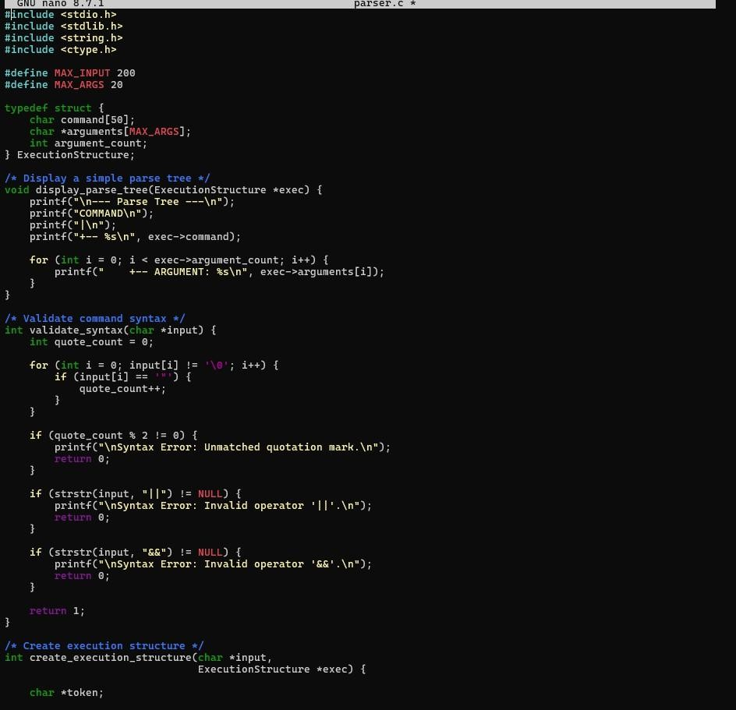

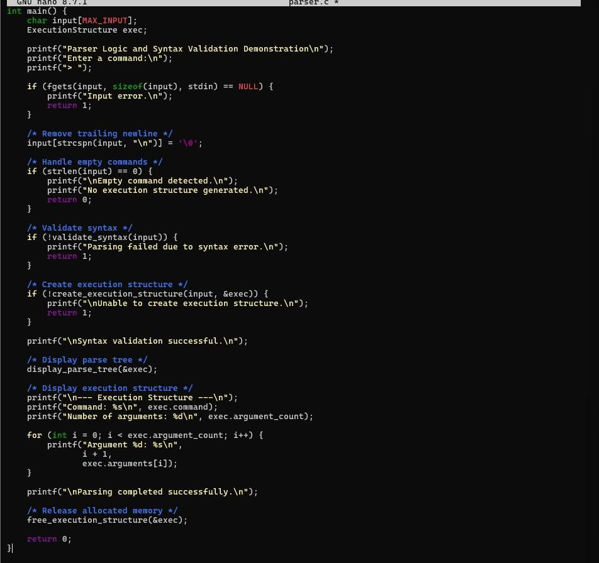

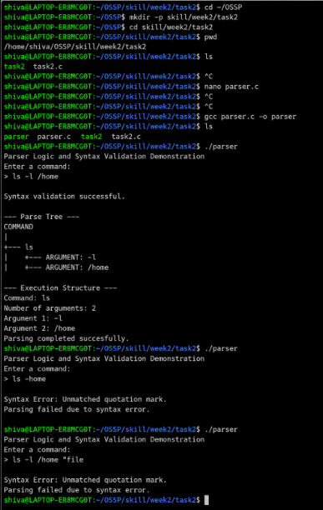
Observation: The parser program successfully validated the syntax of the entered command and generated a parse tree containing the command and its arguments. For the valid input ls -l /home, the command and two arguments were correctly identified and an execution structure was generated. The program also successfully detected an unmatched quotation mark as a syntax error.
Empty command input was handled correctly by displaying an appropriate message without generating an execution structure. Thus, the required parser logic, syntax validation, error detection, parse-tree generation, empty-command

handling, and execution-structure generation were successfully demonstrated.

